WORKSHOP ON THE MIDDLE EAST WATER ISSUES

MIDDLE EAST TECHNICAL UNIVERSITY (METU)
February 2-3, 1996
Ankara/TURKEY

OVERVIEW OF MIDDLE EAST WATERS: A Technical Perspective
(Pre-Workshop Draft)

By Özden Bilen*

INTRODUCTION

Over the last decade, numerous reviews and studies have appeared in books and papers addressing the Middle East water issues. However; these have generally been diluted with multiple political arguments. Foreign interventions in the Middle East have historically always been strong and water issues in this region become an argument in political debates and games. We have been witnessing that news papers abroad are invaded by speculations. In this context, unrelated events were used arbitrarily to form a picture of ruthless economic and political power struggle. But behind this facet, the cool and realistic world of facts and figures about Euphrates-Tigris Basin tells us an entirely different story.

After these introductory remarks, I will focus on the following two major points:

- Hydropolitics of Turkey
- Comparison of Major Rivers in Middle East in Terms of Legal Regime and Technical Aspects.

1. HYDROPOLITICS OF TURKEY

National boundary among Turkey and its neighbors coincides in a number of places with rivers and several watercourses across the boundary. Along the total 2763 km length of boundary, 22 percent of whole length or 615 km formed by rivers. It is not only its geographic location but its neighbors that determine a countries foreign policy. Some authors found strong correlation between the number of borders a country has and the number of external wars it experiences. Before the collapse of Soviet Union, Turkey had six borders, after the Soviet Union underwent transformations and the new Commonwealth of Independent States (CIS) was established, now Turkey has nine borders including three new states namely Armenia, Azerbaijan and Georgia. Countries having many neighbors with differing composition and orientations generally seek to reduce their insecurities by arming or making alliances.

Of the in the region, Turkey has been the most active one in forming and entering into various bilateral and multilateral water arrangements with its neighbors. During the cold war era, in 1973, Turkey and Soviet Union signed a treaty on the Joint Construction of the Arpaçay (Ahuryan) Dam on the tributary of Aras River. After extensive feasibility studies jointly carried out, the dam was built and since 1986, this dam has been operated by a Joint Technical Committee. Regulated river flow is being used by Turkey and Armenia along the both side of river for irrigation and energy production. Iran is a downstream riparian of Aras River, in this context this river is also transboundary river and Turkey and Iran reached a compromise on the construction of Arpaçay Dam.

In a similar vein, an Agreement between Turkey and Greece relating to the construction of Flood Control Works on the Meriç-Evros River was signed at Istanbul February 19, 1955. The Agreement provides for the construction of flood control works in accordance with a master plan jointly prepared. Some of the facilities envisaged by this Master Plan were realized. However, Bulgaria as an upstream riparian country did not participate in this bilateral works and Bulgarian’s position injured the success of the flood control measures.

Based on these experiences, Turkey tried its best to cooperate with Syria and Iraq on the joints projects to create confidence building among riparian countries. In this respect, Turkey proposed several joint projects. These challenges are summarized below.

- The height of the Tishrin Dam located north of Tabqa Dam in Syria is limited to 20 meters. On the other hand, there is Karkamish Dam in the Turkish territory near the border, before the construction of this dam, Turkey proposed instead of two separate dams near to each other, one in Syria and the other in Turkey, if the height of Tishrin Dam in Syria were increased and generated energy shared equally between two countries, this solution would have been more economic. This proposal was not accepted by Syria.
- Then Turkey turned to Tigris and made a new suggestion to built joint dam on Tigris River which is boundary water between Turkey and Syria. This was also rejected by Syria.
- Some areas fed by the Euphrates could be more efficiently commanded by waters to be transferred from the Tigris River. A system of link canals can easily serve to augment the Euphrates-fed irrigation. This possibility constitutes one of the most promising technical solutions to help match supply with demand in the Euphrates-Tigris Basin. Based on this fact, Turkey’s proposal for cooperation joint design and construction of link canals between two rivers was not accepted by Iraqis.
- In 1984, Turkey Proposed its “ Three Stage Plan for optimum, equitable and reasonable utilization of the transboundary watercourses of the Tigris-Euphrates Basin” which comprises inventory studies for water resources, land resources and evaluation of both land and water resources which includes the discussion of methods and criteria for determining economic viability of the planned projects. Turkish proposal with its basin-wide approach follows internationally accepted recommendations and it is the best solution from technical point of view.

All regional cooperation efforts of Turkey regarding water have so far met no positive responds by other riparians.

In the preceding discussion, Turkey’s efforts for cooperation instead of confrontation were outlined. What is the situation in two other river basins namely Nile and Jordan rivers?

2. COMPARISON OF MAJOR RIVERS IN THE MIDDLE EAST IN TERMS OF LEGAL REGIME AND TECHNICAL ASPECTS

Every river basin has its unique technical, socio-economic and political features. Thus the nature of problems concerning the utilization of water by riparian states varies greatly one basin to another.

Euphrates and Tigris together have an average annual water potential of 87.7 billion m³ which is approximately equal to the Nile Basin at Aswan Dam in Egypt. Jordan River has an average annual flow of 1.4 billion m³ which equals only 1.5 percent of Euphrates-Tigris or Nile. This small basin is shared by three states Jordan, Syria, Israel which all have gained their Independence in 1940s. Now, there is a fourth one with establishment of Autonomous Palestine Administration in West Bank and Gaza. In Jordan Basin, territorial disputes have continued for more than half a century, water conflicts have surfaced many times in history and taken different forms.

Jordan Basin

Most of the flow from the upper Jordan and its tributaries is stored in the Sea of Galilee, whence it is borne by Israel’s national water carrier to Israel’s cities, farms and deserts. Jordan’s allocation is scheduled to be increased under the terms of the 1994 Jordanian –Israeli Peace Treaty, although Israel appears to remain in control of deciding how (See Annex).

According to the peace agreement between Israel and Jordan: during the summer period (15 May to 15 October of each year) Israel pumps 12 million m³ and Jordan gets the rest of flow. The arrangement for the main stem of the Jordan River is that during the winter period (16th October to 14th May of each year), Jordan is entitled to store for its use a minimum average of 20 million m³ of the floods in the Jordan River south of its confluence with Yarmouk as outlined in Article II. Excess floods that are not useable and that will otherwise be wasted can be used for the benefit of the two parties including pump storage off the course of the river. How this water is to be allocated is not stipulated in the Agreement.

Available data indicate that the most immediate water problem, starting from worst conditions, occurs in Gaza Strip, West Bank and Israel.

Gaza strip is 360 km² in area and 1992 population has been estimated 750 000. The 1948 population was about 50 000 and has swelled to its present numbers due to the influx of refugees. Population density of the Gaza area is about 2000 persons per square km. This region is the most populated area in the world. Safe-yield of ground water is 65 million m³ , while it is still being pumped at a rate of 90-100 million m³ per year. Israel has established a number of new settlements and dug new wells in Gaza Strip which have tapped the already over-exploited local aquifer.

Israel’s people consume three or four times as much water per head as the Palestinians. Palestinians are forbidden to dig new wells and Palestinians were kept very short, particularly for their crops. Furthermore, Gaza people and Palestinians live in West Banks get a little domestic water from Israel’s national carrier and most of their meager supplies come from ground water aquifer that has been largely exploited and is in badly state.

Nile Basin

The Nile Basin extends over an area of 2.9 million km² and transcends nine riparian states. Nile River Basin encompasses the two sub-basins of White and Blue Niles. White Nile flows through eight of nine riparian states, (Rwanda, Burundi, Tanzania, Zaire, Kenya, Uganda, Ethiopia, and Sudan – all except Egypt), before it joins the Blue Nile at Khartoum and proceeds northward into Egypt and the Mediterranean Sea. Blue Nile, in contrast, rises almost exclusively from the Ethiopian highlands and only three states are concerned with its management: Ethiopia, Sudan and Egypt. Many different countries will be affected developments of White and Blue Niles (See Annex).

Over the last decade little progress has been made in planning for the coordinated development of Nile Resources. The construction of the Aswan High Dam required that Egypt and Sudan reach a new agreement on the allocation of Nile waters. The treaty that resulted from their negotiation –The 1959 Nile Waters Agreement—remains today legal basis for the allocation of Nile waters between Egypt and Sudan.

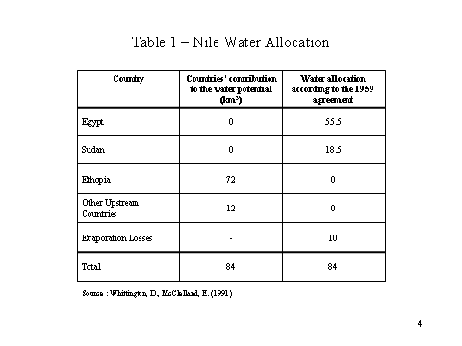
This agreement was based on the assumption that there would be annual mean flow at Aswan of 84 billion m³ an amount arrived at average flow rates between 1900-1959. Egypt and Sudan divided this total, Egypt was allocated 55.5 billion m³ , and Sudan received 18.5 billion m³ .Ten billion cubic meters were assumed to be lost to evaporation and seepage from the Aswan High Dam reservoir. The Nile Agreement does not contain clear-cut terms for the case that the annual quantity of water is lower than what is provided for in the agreement.

The 1959 Nile Waters Agreement did not reserve any water for upstream riparian countries. The Agreement established procedures that Egypt and Sudan were to follow in settling claims of upstream riparians for a share of Nile waters. The Agreement includes the following provision in this respect:

“ …since the other riparian countries on the Nile besides the republic of Sudan and the United Arab Republic claim a share in Nile water, both Republics agree to study together these claims and adopt a unified view thereon. If such studies result in the possibility of allocating an amount of Nile water to one or other of these territories, then the value of this amount shall be deducted in equal shares from the share of each of the two Republics…”

This procedure has never been used. No other riparian countries have made formal claims to Egypt and Sudan for an allocation of water from the Nile. In the Nile Basin, there is an agreement between two downstream countries neglecting legitimate interests of seven upstream riparians. The Agreement thus contains considerable conflict potential. Long term decrease in the flow rate with demand on rise could lead tensions with upstream countries especially with Ethiopia. Blue Nile rises in Ethiopian highlands; White Nile in the central African mountains but on the way to Egypt loses much of its water in the swamps of southern Sudan. Ethiopia, which supplies the bulk of water as an upstream country, suffers from dreadful famines and would clearly like to store water and so increase its food production. Thus, Egypt is vulnerable. But, by sheer dominance, it has protected what it regards as its historic rights. Ethiopia does not have the financial sources to develop its own projects and Egypt has power to deter international contributions.

Euphrates-Tigris Basin

Situation in Euphrates-Tigris Basin is completely different and better off. Turkey took into consideration the legitimate interest of two other riparian countries of being protected against appreciable harms by making an unilateral pledge of releasing an average monthly quantity of water ( 500 m³ /second) at the Syrian border according to the provisional Turkish-Syrian Protocol of 1987. This amount of water is equal to 50 percent of long-run average annual natural flow, while the contribution of Syria and Iraq to Euphrates waters is almost zero. Furthermore, not only is the Euphrates run-off in the natural state highly variable regionally, but also it varies dramatically from month to month, and indeed from year to year.

The provisional agreement also provides for the possibility that 500 m³ /second may not be reached in a given month, in the following month, however, the shortfall must be made up for. The risk of year to year fluctuations is borne by Turkey. Turkey has far greater water storage capacities as compared with in Syria and Iraq. In addition; evaporation losses in Turkey lower than Syria and Iraq. However, Turkey must insist on more equitable allocation of the risk of fluctuating flow rates in future negotiations on final allocation of waters. Provisional Protocol terms should be negotiated in this respect since it is only agreement in the World that imposes the risk of fluctuating flow rates on signatory state. In the face of unpredictable hydrological and economic changes, this protocol is not sustainable for a long range of time.

In conclusion, Turkey has always pursued good neighborly and friendly relations with Iraq and Syria and always defended reasonable, equitable and optimum utilization of transboundary waters. In Nile and Jordan basins water conflict becomes zero-sum contest but in the Euphrates-Tigris Basin, there are cooperative efforts which are outlined in this paper. In spite of the doomsday scenarios envisaged by some experts, implementation of solutions proposed by Turkey can contribute to peace and prosperity in the Euphrates-Tigris Basin.

ANNEX: Nile River Basin

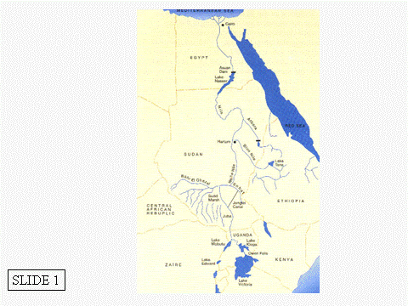

ANNEX: Jordan River Basin

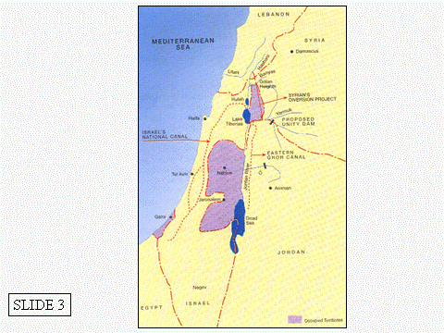

Annex: Schematic Map of Euphrates-Tigris Basin

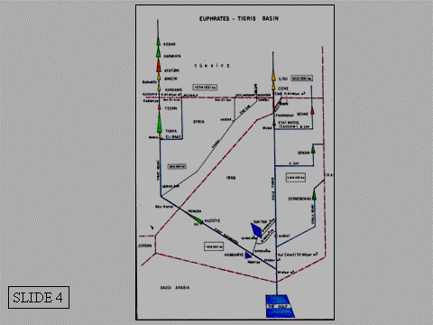

* Director General of State Hydraulic Works (Retired)
Oral Sander (1993): Turkish Foreign Policy-Forces of Continuity and of Change, Turkish Review Quarterly Digest, Winter 1993 Vol.7, No.37, pp 31-46.
Ibid
See Treaty Annex II, Article I: Allocation
See Treaty Annex II, Article II
Dale Whittington and Elizabeth McClelland (1992): Water International, 17(1992) 144-154 © IWRA.
Raj Kirshna (1986): The Nile River Basin- Paper presented at the Center for Strategic and International Studies (CSIS), Georgetown University, Washington DC.

