WATER SCARCITY MANAGEMENT

Introduction
The relationship between natural resource scarcity and security has been increasing importance during recent years and debate on this relation has explicitly linked with political and economic stability of states. Since water is so vital to the human, water scarcity takes place in the core of this debate. This paper, therefore, will review major issues surrounding water scarcity.

Taking into account the different aspects of the problem, before investigating the main trends and aspects of the current state of the world fresh water supply and demand, some basic conceptual issues with regard to water scarcity will briefly be examined in the first section of the paper. This section is designed to serve as a background and input for further discussions in other parts of the paper. Section 2 provides a general overview of the water situation in the major regions of the world. Section 3 goes on with a summary of causes and effects of water scarcity that are needed for threat assessment to global security. Section 4 endeavors to describe very briefly the policy responses and options to challenging threat to security. Finally, some recommendations for the future activities are outlined.

1. What is water scarcity? : Some conceptual issues

In various studies, water scarcity, water shortage and water stress are being used interchangeably. Although, there may be a need to reduce the present confusion because of the widespread use of the same words for different things, the author of this paper is not too enthusiastic about refinement to define the terminology and go into details in this respect.

In my mind, it would be better to simply concentrate on the concept of ‘water scarcity’ as excess of demand over usable water in given region.

The issue of measurement and quantification of water scarcity is regarded as a priority area by many researchers and policy making institutions. In fact, there is a need to develop a common acceptable indicator.

Water availability can be measured by annual average flows (in cubic meters) per head of population or its reciprocal, namely the number of people dependent on each unit of water (e.g. one million people depend on one billion cubic meters of water). Since the hydro climate and hydrograph of a country determine the potential water availability in rivers, streams and other surface flows, indicator defined above is also called as ‘Standard Hydrological Index (SHI)’.

In order to make comparisons among countries or regions using ‘SHI’, attempts have been made to define a threshold under which a country may be considered in a situation of water shortage. The limit of 1000 cubic meters per person is often quoted as representing a condition of severe water shortage. Food and Agricultural Organization (FAO) of the UN estimates that 20 countries will be at or below this level in the year of 2000 (FAO, 1993). Most of these are in the Middle East and the North Africa (MENA Region). At levels of water availability less than 2000 m³/caput, water is regarded as a potentially serious constraint, and a major problem in drought years. Forty countries will fall into this category.

Defining and quantifying water scarcity by standard Hydrological Index (SHI) at a national level in relation to a ‘normal’ year is problematic for number of reasons:

- First, standard indicator of water scarcity ignores regional differences in water supply within the whole country and masks extreme local variabilities. For example, The European part of Turkey, Central Anatolia and some regions in Western Anatolia have serious and growing water shortages and intersectoral competitions. Even countries which are generally humid, experience troublesome droughts, and regions within them may experience water scarcities comparable to those of countries that are much more arid. Northern China, western and southern India, parts of Mexico and some regions of USA and Italy are periodically or permenantly drought prone. Whether it is feasible to relieve their scarcity by transferring water from other parts of the same country is a matter of hydrology or economics.

- There may be great differences in per capita water availability whether it is calculated according to the total water potential or usable part of it in a country. Extremely irregular precipitation and flow conditions are the factors which limit the utilization of water resources economically and these conditions may require dams of large volume. This particular factor which further exacerbates economic and geological problems and may also block the realization of a project in some cases and thus largely limit the utilization of water resources.

- Expressing water availability by SHI takes no account of fossil water or large underground aquifers where these are feasible resources.

- Finally, scarcity is partly a social and economic construct and it is difficult to capture in a single quantitative index (Winpenny, 1997). That is why, some researchers developed ‘social water scarcity’ concept.

Water scarcity is heavily influenced by social and economic factors, lifestyle, technical factors such as supply and storage, institutional and policy factors, water quality etc… An industrializing society with large irrigated farming sector is likely to encounter water scarcity earlier than a country at a different economic and social structure. Social problems might feed back to the water scarcity problems. Should two nations having roughly the same and high level of water scarcity are compared, one of them could be significantly better off (if not necessarily flourish) and manages to live on per caput allotments below what was considered in possible, due to the higher adaptive capacity. Adaptation is more difficult in developing countries due to their common shortage of social institutions, resources and technical expertise for addressing scarcity.

In order to make quantitative and qualitative analysis of the social and economic implications of water scarcity, ‘Social Adaptive Capacity Indexes’ developed by Leif Ohlsson and B. Appelgren (1998) are interesting approach to this issue.

L. Ohlsson suggests that an index for ‘Social Water Scarcity’ could be constructed through dividing standard Hydrological Index (SHI) by the Human Development Index (HDI) published annually in UNDP’s Human Development Report. Social Water Scarcity Index (SWSI) proposed by B. Appelgren is arrived at dividing SHI by the product of GNP per capita and institutional capacity rating.

Ranking of states according to the ‘Social Water Scarcity Index’ would point at the level of urgency for water management measures in each country such as conservation, institutional and legal reforms, protection, and economy of use. The particular relevance of social adaptive capacity in this context is that a country having a better social adaptive capacity may be better off than a similar water scarce country as measured by standard hydrological index (SHI). However, semi-qualitative indicator namely, ‘Social Water Scarcity-SWSI’ is not yet well developed and research on this issue is still at stage of conceptualization rather than the stage of mature data integration and evaluation.

However, the standard Hydrological Indicator (SHI) of water availability, because of its virtue of simplicity, is being used as ‘an early warning indicator’. Yet, a resource analysist should be aware the above mentioned points while he is using per capita water availability for assessing water scarcity issues.
2- The World Fresh Water Supply/Water Resources Uses and Trends

- Water Supply

The supply by rain on the world’s land is about 110 000 cubic kilometers (km³)∗ per year (Abernethey, 1996-Ambroggi, 1980) of which 70 000 km³ is evaporated from waters on the continents and transpired by natural vegetation.

Most global rainfall occurs in the equatorial zone that stretches from South and Southeast Asia into Central America and the Amazon Basin. In general, rainfall decreases north and south of this zone.

Where as continents receive 110 000 km³ of water per year from precipitation, they lose 70 000 km³ of water to evaporation and transpiration so that net effect of this hydrologic cycle is approximately 40 000 km³. However this estimate of global fresh water supper has an error margin of ± 10 percent a according to the several researchers (McDonald and Kay, 1988).

Although the net continental flow is about 40 000 km³/year (cubic kilometers per year) all of it is not available for man’s use.

Much of it flows into the sea without use as floods, and will continue to do so, either because the flow rate is too large to capture through storage facilities or because it is held in the soil or in the swamps.

The maximum that might reasonably be used to satisfy human needs is about 14 000 km³/year which is ‘base flow’ or ‘stable runoff’ excluding flood waters. Of this volume about 5000 km³/year flows in regions that are uninhabited and are likely to remain so because they are climatically unsuited to human settlement. Hence the effective world water resource, from which all needs will have to be met for some years to come, is in the range 9-14 km³/year.

Although large quantities of water are available on a global scale there are distinct variations in its availability in different regions and freshwater on the Earth is unevenly distributed.

The uneven global distribution of freshwater is striking. By itself, the Amazon River accounts for 20 percent of average global runoff, compared the all of Europe with only seven percent. The Zaire river basin accounts for 30 percent of Africas total runoff (Butts, 1997).

The distribution of water on Earth by region and per capita is shown in Table 1 (World Bank, 1995). This table indicates some principal dimensions of our problem and gives a rough sense of regional variability of the problem.

Table 1: Worldwide Net Renewable Water Distribution by Region and Per Capita
Net Annual Renewable Water Resources (billions of cubic meters) |  | Population  (millions) | Per Capita  (cubic meters)
Oceania | 769 | 21 | 36 619
Latin America | 10 766 | 466 | 23 103
North America | 5 379 | 287 | 18 742
Eastern Europe and Central Asia (ECA) | 7 256 | 495 | 14 659
Africa | 4 184 | 559 | 7 485
Western Europe | 1 985 | 383 | 5 183
Asia | 9 985 | 3 041 | 3 283
MENA | 355 | 284 | 1 250
World Total | 40 679 | 5 536
Sources: World Development Report, 1995; and World Bank estimates, 1995.
In terms of the region-wide average per capita water availability, not surprisingly, MENA (Middle East and North Africa) countries are in the worst condition. Although the average for those countries are 1250 m³/caput, this average masks extreme variability. For example, in Yemen and the West Bank and Gaza per-capita availability today is 176 and 105 respectively and far below the regional average.

If we examine water situation in countries, Southeastern China benefits from seasonal monsoons and has sufficient water supplies, while the North China plain, a fertile area that accounts for 25 percent of the countries grain harvest, has water scarcity problems. Over-pumping aquifers to support wheat and millet cultivation has caused approximately one third of Beijing’s wells to go dry, with the water table dropping between one and two meters annually. This condition is indicative of water scarcity problems of this agriculturally and industrially important region of the country. China’s situation is particularly important since that country, with approximately one-quarter of the World’s population can claim only eight percent of its freshwater resources (Butts, 1997). Unlike the case of other national resources, it is sometimes difficult to declare that certain countries do or don’t meet standards for water sufficiency. Nevertheless, World Bank statistics (like FAO) identify approximately 20 countries that have been declared chronically water scarce. The list includes Saudi Arabia, Israel, Jordan, Kuwait, Egypt, Kenya, Somalia and Singapore (Postel, 1993). Other strategically significant countries with pronounced rainfall variability include Pakistan, India and Mexico.

Global averages of per capita water availability, only tell us that this is a widely shared problem. There are huge local and temporal variations about these averages.
(ii) Water Use Trends

The trends in world water use during the second half of the 20th century are presented in Figure 1 and Figure 2.

Figure 1 indicates that global annual abstractions of water out of natural system of rivers and lakes was about 1360 km³/year in 1950 and will be estimated as about 5000 km³/year in 2000 (Abernethy, 1996). In other words, global water abstractions during the period 1950-2000 increased by more than three-fold. In 1950 we were abstracting some 10-15 percent of the abstracable total; now we take perhaps 35-50 %, and if present rate of increase continue we can expect to reach the ceiling (in terms of global averages) in some 30-50 years from now.

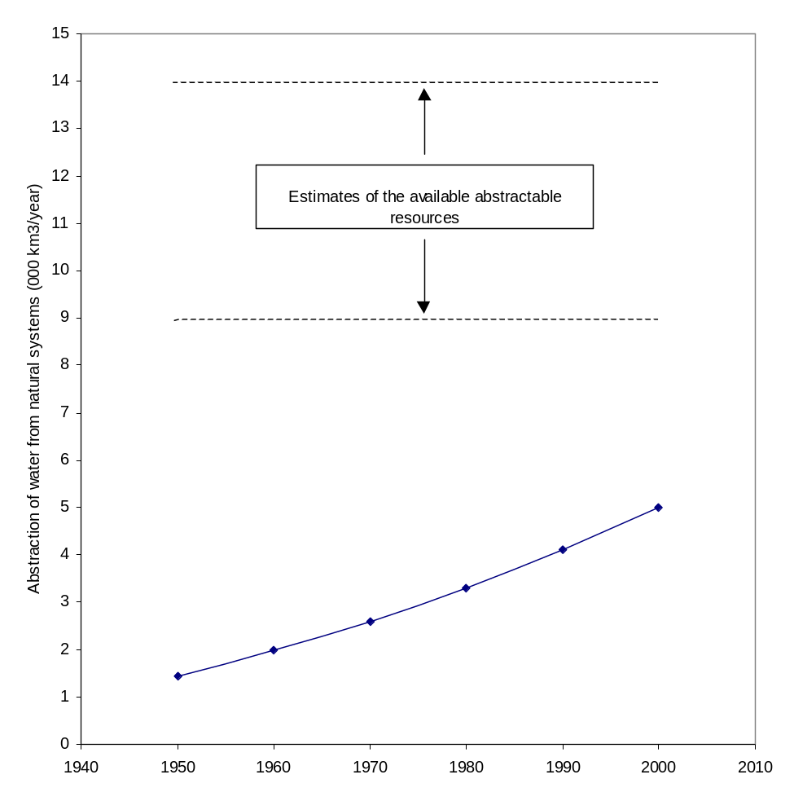Figure 1: Annual global abstraction of water from the natural system

for human use

Source: Abernety (1996, quoted from Meybeck, Chapman and Helmer)
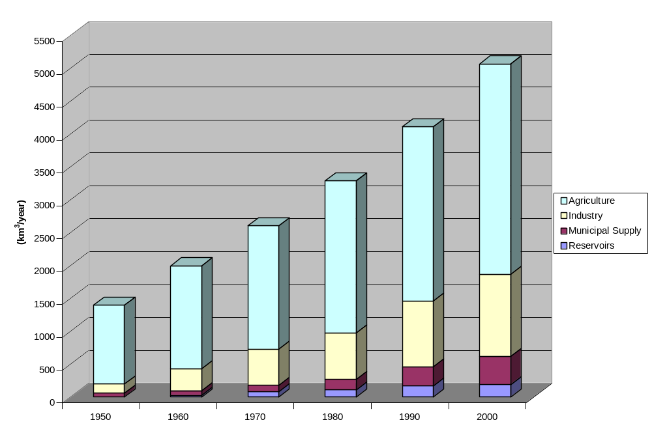Source : I.A. Shiklomanov, 1990. Global Water Resources Nat. Resour., 26: 34-43
Note: Consumption by reservoirs is through evaporation

Figure 2: World Water Consumption According to Use

According to the Figure 2, agriculture’s share in overall global consumption was 85 percent in 1950 and dropped to an estimated 65 percent in 2000 (as global averages). During the same period industrial consumption had grown to 25 percent, while consumption by cities increased from 2 percent to nearly 9 percent.

The Figure 1 and 2 donot take into account agricultural uses under ‘rain-fed’ conditions. Currently, 70 percent of the world’s cultivated land is watered exclusively by rainfall and half of world’s food comes from rain-fed agriculture. Although large amount of water used there never enters the accounts of natural streams, the moisture availability (= green water) is as important as the availability of renewable surface flow (= blue water).

Water uses also vary regionally like global supply of fresh water. The following Table 2 indicates levels of abstraction per person in the different continents.

Table 2: Annual abstraction of waters in different regions of the world.

 | Total water use per person | Agricultural water use per person | Non-agric.  Water use per person  m³/year
North and Central America | 1692 | 829 | 863
Former Soviet Union | 1330 | 864 | 466
Oceania | 907 | 308 | 599
Europe | 726 | 240 | 486
Asia | 526 | 452 | 74
South America | 476 | 281 | 195
Africa | 244 | 215 | 29
World | 660 | 455 | 205
Source: World Resources Institute, 1992

It is quite misleading to compare water resources and their consumption or demand at the global or even at the continental level; one has to look at the issues at a level smaller than continental or sub continental. This means also that assessment and comparison of water resources of large countries might be meaningless because average figures may conceal areas of both favorable and difficult water resources situation within the one country.

Consumption use of water in the world is around 5000 km³ per year and a ratio between available resources and their use at the global level looks quite favorable but, in fact, is not so for some parts of the world. The average global figures hide enormous local differences in the water supply/demand ratio. Therefore, global water issues and water-related problems are, in fact, an amalgam of the local problems.

Furthermore, Table 2 says that the big users are not the developing countries but the richer industrial countries of the temperate zones. On average, Africans only about a quarter of what North Americans use for agricultural purposes, and 3 % of which North Americans use for other purposes. Even in Asia, where about 70 % of world’s irrigated land is, uses quite moderate amounts for agriculture.

Although water is abundance in Africa, poverty has a tremendous impact on Africans water resources. Africa has not developed irrigation to the same extent as other developing areas, particularly in Asia. For example, India-which has only about one-tenth the surface of Africa-irrigates five times as much land (Kandiah, 1998).

Water uses differ greatly depending on socio-economic conditions. For example, Table 3 illustrates that agricultural water use is higher as proportion of total water use in the low-income countries (91 percent) than in high income group (39 percent). Nevertheless, on per caput basis, the high-income countries use more water for agricultural basis than the low-income countries.

Table 3: Sectoral Water withdrawals, by income group

Country  Income  Group | Annual Withdrawals per caput | Withdrawals by sector
 |  | Agric | Ind. | Dom.
Low-income | 386 | 91 | 5 | 4
Middle-income | 453 | 69 | 18 | 13
High-income | 1167 | 39 | 47 | 14
Source: World Bank.1992 World Development Report 1992, based on WRI data.

Table 3 suggests that as countries become richer, their consumption of water for agriculture increase relatively little, but non agriculture uses grow enormously so we should expect that the economic success of east and south-east Asia will generate non-agricultural consumption of water.

Some countries with relatively good water resources and low population density but a lower level of development, can most probably encounter the water scarcity earlier than a developed country with large irrigation facilities. In fact, more than one billion people live in countries where there is no water shortage, but they are in actually ‘water stress’ (Gujja, 1997).

In this case, main question is why those countries are not having ‘water security’ hence food security? Answer is simple: these countries are in poverty and under developed with huge economic and institutional problems. If they remain at the present state of development, the social security, food security, quality of life will further worsen leading to significant negative impacts on environment and global security.

This analysis shows us that water can be scarce in different ways. In my thinking there are two major category of scarcity with different implications:

- Water scarcity due to low utilization: current utilization ratio as a percentage of total available resources can illustrate the scale of problem and the latitude for policy makers. Water crisis in some parts of the world is not due decline in resource itself in per capita terms, but because of the very low utilization ratio. About 40 developing countries, particularly in Africa, use less than one percent of their annual renewable freshwater and consumption in some of these countries is as low as 25 cubic meters (world average 660 m³ - see Table 2). As mentioned above major constraints to water resources development in Africa are of economic social, institutional and political nature. These constraints must be reduced or eliminated to permit increases in agricultural production through irrigation or the development of rainfed agriculture.

- Water scarcity due to high population density and/or aridity: In this case, per capita water availability can show us competition for water in rivers and aquifers with implications in terms of dispute over quantity and quality of water in fact, water scarcity is directly related with per capita water availability and growth in population. Middle East and North Africa (MENA) is poorly endowed with fresh water supply (see Table 1). Population in this region, having more than doubled in the past 30 years to about 280 million, could double again in the next 30 years. Cities growing at more than 4 percent a year already contain 60 percent region’s people (World Bank, 1994). Water demand for domestic and industrial uses has exploded in recent decades. All of these factors are generally combined with poorly endowed natural fresh water supply.

Very low utilization of available water resources or water scarcity as a result of no development is a serious problem in many developing countries. Water scarcity is defined by local conditions, and not necessarily only from water availability indicators. However, the most of the debate revolves around the increase in population, decrease in water availability, etc. Such a debate is needed but considering following fundamental facts:

- Population will grow and their needs will grow,
- People in many countries will need more water than today,
- Ecological problems do pose constraints,
3- Causes of Water Scarcity

As the discussion on the causes of water scarcity, a distinction has to be made between ‘natural water scarcity’ and ‘human driving forces’.

In this respect, scarce water resources and their distribution can be a direct cause of water scarcity, whereas, in general, social and economic problems and environmental degradation are also causes of water scarcity. Neither of these problems by itself necessarily leads to resources scarcity. The brief discussion below illustrates these points.

- Growth in population and population pressure

Global population continues to increase, reaching 8 billion people by 2025. While providing water and water related services to a population that increases 33 % from today’s 6 billion is a major challenge.

Classical Malthusian discourse argues that as population grows, water scarcity increases and leads ultimately to violent conflict. Whereas Malthusian pessimism envisages water conflicts with some confidence, the counter argument ‘the virtual water concept’ was developed by Tonny Allan (Allan, 1993). Assuming that 1000 cubic meters of water is needed to grow one tone of wheat and one million tons of wheat is imported, the water equivalent of this wheat will be one billion cubic meters. Water defined in this example is termed ‘virtual water’ by Prof. Allan. If food is available on favorable trade terms, the gab in the production of basic food stuffs can be closed by imports. Thus water has to be indirectly imported through food, especially cereals, from regions with more water supplies. The water saved through such importation may find greater value when used in drinking water sector and in industry, because agriculture is infamous for its excessive use of water.

Instead of looking at statistics of population/water availability rations which posits a linear relationship between population growth and water scarcity, Allan examined food imports and exports as indicators water scarcity and possible options for changes in water use policy.

World population is increasing at a compound rate of 1.7 % per year, producing a doubling time of about four decades and any long term solution of the water crisis has to include steps to reduce population growth.

However, in area where each national group seems to locked in a demographic race for numerical superiority, this is not very likely to occur. The refusal of family planning may not be due so much to religious values, but more to political anxieties relating to the perception of “ a demographic race” between countries. Therefore, the demographic policies will probably not be reversed as long as the political crisis is not solved.

To this end, water policy would have to be complemented by a simultaneously implemented comprehensive population policy.

- Environmental Degradation

Water scarcity are in many cases closely related to environmental degradation because the latter can cause scarcity by damaging or altering the hydrological circle of water or in other words regenerative processes involved.

- Modification in land use pattern.

The degradation and land use conversion may reduce the amount of usable water available downstream. With growing human populations more and more land is required for shelter, food production, forage requirements and fuel wood. Since good agricultural lands are already being used, people are forced to use marginal lands. Forests are cleared so that the land can be used for agricultural purposes. However, environmental degradation of such areas is main symptom of the problem but not the problem itself. Major problem is economic conditions of the rural poor who are forced to exploit the environment for their survival. Poverty feeds back to environmental problems. As the economy and the environment are inter-related it is difficult to differentiate between their role in water scarcity.

The same processes mentioned above can also reduce existing water storage capacities by silt deposition in reservoirs. While the problem is global in nature, the magnitude of problem varies from country to country.

- Global Climatic Change

While in the past, the evaluation of man-made changes to the climatical change seemed to be a rather academic exercise without practical implications; to some scholars it has become quite obvious at the present that such changes can have a significant impact on the environment.

There is a view that global warming is occurring due to the green house emissions such as carbon dioxide (CO₂) and methane. Although I have some reservations on this issue; the permanent increase of CO₂ and other gases in the atmosphere tend to influence climatic zones. Climatic zones are likely to migrate, leaving the climate of some regions dryer, others wetter, and all more variable and unpredictable.

These issues have been addressed at a number of international meetings, starting with Vienna Conference of 1985 and the Montreal meeting of 1987. The UN Conference on Environment and Development (UNCED) in 1992 established the framework for future actives and in the same year, Kyoto Conference set specific targets on global-warming reduction. According to the Kyoto Protocol, governments to pledge to cut greenhouse emissions worldwide by 5.2 percent below 1990 levels. This is an average figure varying with countries and regions. For example, the target value is 8 percent for the countries of the European Union and some Eastern Europe Countries, 7 percent for the US and 6 percent for Japan, Canada, Hungary and Poland (Bals and Treber, 1998). In order for the Kyoto protocol to come into force, 55 countries must ratify it. So far, only 29 some developing countries have done so.

In November 2000, at The Hague, representative of 160 countries gathered to assess progress since 1997 Kyoto Protocol.

The Hague meeting clearly indicated the familiar divisions between rich and poor countries, with the latter arguing that they cannot afford to put the brakes on their own domestic industrializations.

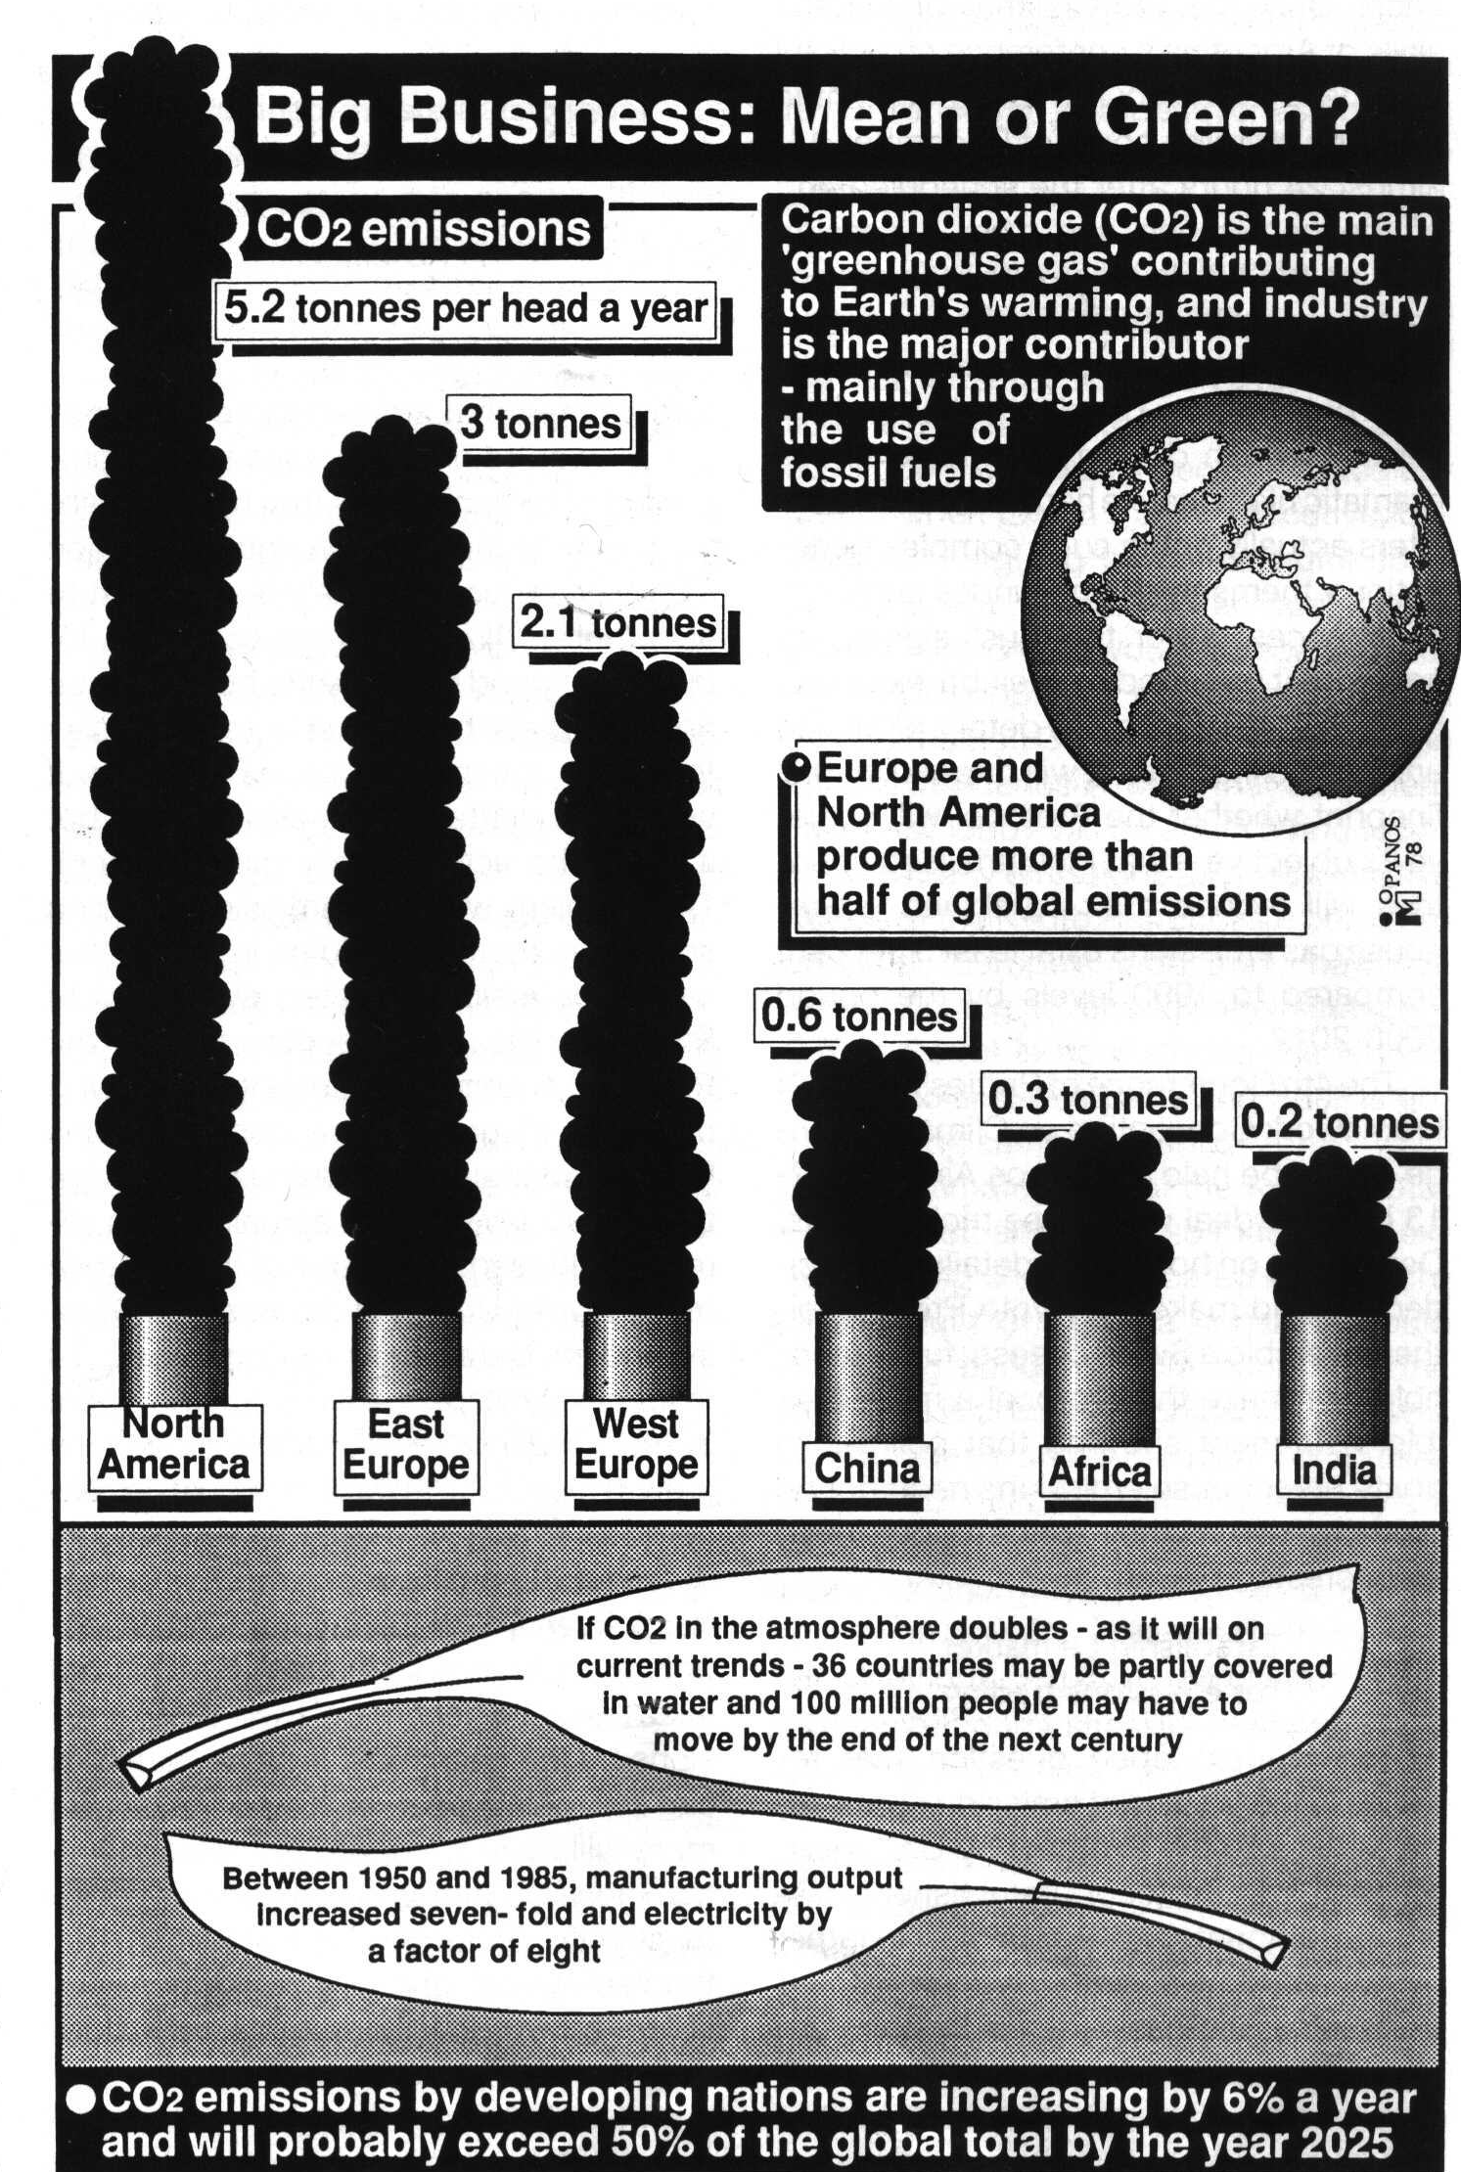
The following Figure 3 compares different regions in terms of CO₂ emissions per person per year (DSE, 1998).

Figure 3: Carbon dioxide emissions by region and per capita

Above figure indicates that Europe and North America produce more than half of global emissions.

Some climatologists have been arguing that the trend in global warming may be irreversible at least over the most of coming century. This means that precautions can be taken to avoid jeopardizing the well-being of human society by adapting our water resources systems to the new conditions as early as possible. However, campaigners for drastic cuts in emissions fear that talk of ‘adapting’ rather than ‘mitigating’ will ease political pressure on the big polluters such as the US and Japan.

- Pollution of Water Resources

Water scarcity is not only a problem of the amount of water availability but increasingly as well a problem of deteriorating water quality. Solid and liquid wastes of all types generated by industrial and agricultural activities seriously pollute both surface and ground water resources. Especially those resources close to urban settlements are under severe threat.

Although the dimensions of pollution are known, there is yet no comprehensive work especially in the developing countries to address this problem. If necessary precautions are not taken now, the possibility of utilizing some rivers will be completely lost in the 21st century or this possibility will require immense costs of purification.

Almost 10 years have passed since the end of ‘International Drinking Water and Sanitation Decade’ (1981-90) declared by the UN Mar del Plata Water Conference, yet 1.2 billion people in developing countries still lacked access to safe drinking water in 1997, and 2.9 billion still lacked adequate sanitation facilities (see Figure 4 and 5).

Water and sanitation related diseases are increasing. The World Health Report (WHO, 1999) estimates that water-related diseases caused 3.4 million deaths in 1998.

The Following Figure 4 and 5 show us ‘Number of people without safe drinking water and without adequate sanitation facilities’ respectively.
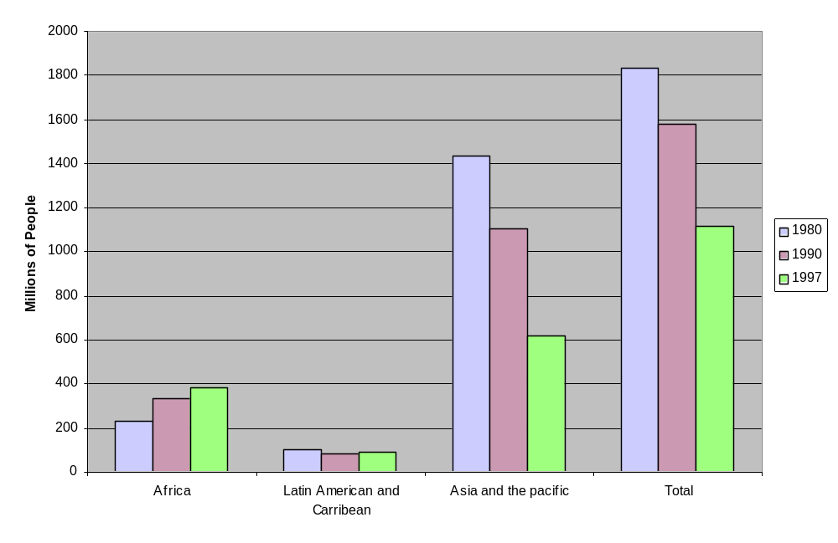Source: World Water Vision (1999)

Figure 4: Number of People without Safe Drinking Water

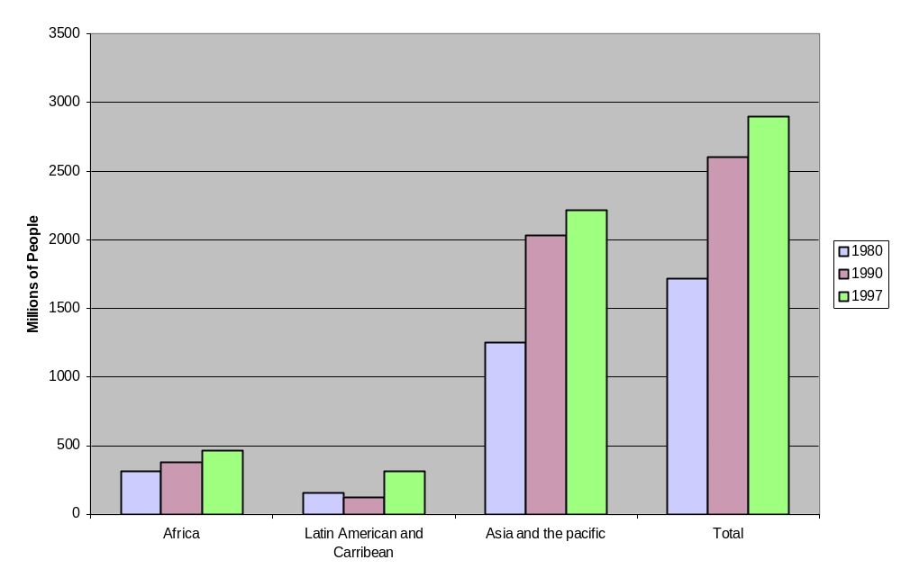Source: World Water Vision (1999)

Figure 5: Number of People without Adequate Sanitation

According to the Figure 4, more people have gained access to safe drinking water since 1980 than ever before and worldwide the provision of new water services is outpacing population growth (World Water Vision, 1999).

However, growing number of people have inadequate sanitation facilities and global provision of sanitation growth. Between 1990 and 1997, the number of people without adequate sanitation rose from 2.6 to 2.9 billion (Figure 5). Inadequate sanitation and industrial waste treatment is not only a health hazard to humans but pollutes aquatic ecosystems, sometimes with disastrous results.

World Bank and other international finance institutions should have more focus on this issue in developing countries and provide more funds for sanitation facilities.

- Financial and Institutional Problems

In many cases, a country’s water resources are not being developed because of financial shortages. Although development strategy of many countries envisages significant investments in the water sector, economics of those countries are affected by negative balance of public expenditure and reduction of this deficit is in many cases, a matter of national priority. Besides, most developed countries are now saddled with very high level of debt burdens.

Water management can be rational only if the institutions responsible for such management are efficient. As a general rule, it may be said that most water management institutions in developing countries need significant strengthening.

4- Water Scarcity Management:

In order to manage water scarcity, solutions could be divided into two broad categories. These include:

- Supply-side measures
- Demand-side measures

Where available water supplies are judged inadequate to meet current and future demands, the first step usually have been to explore the possibility of enlarging the water supply through readily available technical means for long-term solutions. The need for seeking to enlarge supply may arise from competitive use of surface and ground resources.

Generally speaking, the first category, namely supply-oriented solutions have received more attention during the past decades and amazing records were set in the second half of the 20th century in developing water resources and putting them at the service of populations. For example, 90 % of 37000 large dams were constructed after 1950, parallel to this, total area to be irrigated increased from 74 million hectares to 274 million hectares at the end of the 20th century. This development played an important role in providing food security to an ever increasing world population which reached to 6 billion at the end of the century.

However, especially since the start of the 1970’s it was realized that measures geared to increase the quantity of water exclusively through physical facilities failed to respond the needs of growing world population. Consequently, discussions at international forums began to include such new topics: the prevention of water pollution, other environmental problems, public participation in water management, water pricing, and introduction of legal and institutional measures, possibilities of privatization in the water sector, consideration of economic efficiency in the sectoral allocation of water. In other words, the concept of basin-wide water resources development and management was enlarged and has gained more dynamic nature.

Differences between two approaches (two categories) can be exaggerated, and some solutions overlap the two categories. However, the distinction is a useful way of organizing policy options. The following tables summarize the main policy measures in each of these categories (Winpenny, 1994).

Table 4: Supply-oriented measures water-scarcity management:

- Surface-water capture and storage.
- Long-distance conveyance and inter-basin transfer.
- Groundwater exploitation.
- Catchment area (watershed) management.
- Conjunctive use of surface water and groundwater.
- Dual-quality water standards.
- Desalination.
- Other non-conventional solutions.
- Pollution control.

Table 5: Demand-management measures

1. Enabling conditions

Institutional and legal changes,
Utility reforms
Privatization
Macro-economic and sectoral policy.
2. Incentives
Marked-based
Active use of water tariffs
Pollution charges
Groundwater markets
Auctions
Water banking
Non-market
Restrictions
Quotas
Norms
Licenses
Exhortations
Public awareness raising Information
3. Direct interventions and programs
Canal lining.
Leak detection.
Water-efficient user appliances.
Industrial recycling; re-use.
Water efficiency.

Each country has unique options among several measures listed above and choice will depend on its level of development, hydrological situation, political and social institutions, management skills, financial resources and others.

Supply-side management involves activities and policies that increase the supply of fresh water available to a region. Demand-side management determines how this supply is used and abused. Thus, demand management involves both allocating scarce supplies among sectors such as irrigation, households, industry and various in stream uses and determining the conditions under which individual users within a sector use water.

It would be redundant to give the detailed descriptions and complex technical suggestions with regard to the majors shown in preceding Tables 4 and 5. The principal water policy issues now receiving national and international attention are outlined below.

- Supply-Side Management

Water projects such as construction of dams, wells for groundwater exploitation, inter basin water transfers are generally promoted as supply-side majors that add to regions water supplies.

Dams prevent or mitigate devastating floods and catastrophic droughts. They modify natural runoff with its seasonal variations and climatic irregularities to meet the pattern of demand of irrigated agriculture, power generation, domestic and industrial water supply. In addition they provide recreation, attract tourism and promote fisheries. We simply cannot manage the World’s limited, unevenly distributed and in many places acutely scarce water resources without dams.

However, there is a dichotomy between those who favor a technical fix to the problems of water supply and those who suggest that technical solution will never solve this resource problem. Currently water development in the south receives a much higher level of priority in the countries of the north which are all in temperate regions. The climatic differences to water development and management between the countries of the north and south have received a scant attention by the some development experts.

Since some years, but recently with increased intensity, a campaign against the construction of large dams and even against any kind of dams is going on and developing strongly. This is certainly an extreme position and to suggest that large scale projects are not relevant to the needs of developing nations, where the water supply problems are huge, is clearly non sense.

It is true that some water development projects have contributed to social and environmental problems in the past. Policy makers and engineers have a professional duty to ensure that these are minimized and benefit maximized, so that latter significantly exceed the former and the final cost is socially acceptable all round.

Despite all conventional water supply measures, demand will eventually outpace supply and new sources of supply will be needed. One of the most promising alternatives for the long-term water supply –particularly in the Middle East- is seawater desalination. Human’s future resource of water is the sea., but not before every drop of fresh water is exploited for drinking and every drop of reclaimed sewage has been treated to the standard of unrestricted use in agriculture. Disposing untreated wastewater is causing serious environmental problems as well as polluting surface and groundwater. Treating and reusing wastewater in agriculture can conserve resources and reduce resource pollution.

The cost of treating wastewater for irrigation averages about 45 cents/m³, significantly less than many alternative sources of supply. Desalination costs have fallen from more than US$ 4 a cubic meter to between US$ 1 and US$ 1.5 today (World Bank, 1995).

During the transition period from freshwater to seawater sewage reclamation (reuse of wastewater) seems an immediate environmental and economic solution in water scarce regions such as Middle East and North Africa (MENA). The estimated cost of options for enhancing water resources is given in Table 6 :

Table 6: Alternatives in the Development of Water Resources

Alternatives | Estimated Cost (US cents/m³)
Re-use of waste water in irrigation | 30-60
Desalination of brackish water | 45-70
Desalination of sea water | 100-150
Prevention of illicit uses and leakage, introduction of water saving devices in homes and enterprises | 5-50
Source: World Bank Estimates (World Bank, 1995)

- Demand-Side Management

When demand grows faster than supply, eventually demand management is required to bring use in balance with supply.

Water demand management policies and practices are defined as making more efficient use of existing supplies through institutional operational economic and socio-political means.

Most water authorities respond to scarcity by non-price devices, such as rationing, prohibited uses, exhortation or cutting of supplies. Although these crude and potentially costly forms of demand management tools could be acceptable only during emergencies such as major drought and break downs of a supply system, these majors donot represent a desirable method for bringing long-term demand into line with supplies and donot take into account of the relative value of water in different applications.

International initiatives such as, Dublin Principals of 1992 and Agenda 21, acknowledged that water has an economic value in all its competing uses and should be recognized as an economic good. This signifies a major conceptual shift since water has been traditionally treated as a free public good belonging to everybody. The new understanding requires a major policy reform in the pricing of the water. In this respect, appropriate pricing policy is important both as an instrument of demand management to encourage efficiency in water use and as mean for revenue mobilization to finance water resources investments. Such economic instruments for demand management send to consumers signals of scarcity and encourage them to save water.

Demand-side management options are a more recent phenomenon than water supply. Efficiency and conservation became concepts in policy and planning after 1970s, but serious attention to demand management problems has tended to depend on a perception of crisis. The oil price shocks in the early 1970s focus attention on demand side management in the electricity sector in many Western countries. Water scarcity and the threat of water shortages is a driving force for more efficient water use in many countries but the response has not been universally translated into concrete action in fostering water-efficient practices.

5- Recommendations

Many countries confront the prospect of emerging water scarcity in the long term and for some that spectra is already on them because of decrease in the supply of water resource, increase in demand or unequal resource distribution.

All the research on water scarcity problems has advanced steadily during last two decades, there is a specially lack of data on possible policy effect of global climate change on the world water supply, water demand and world grain crops.

It is therefore recommended to define and implement a comprehensive and integrated framework for decision-making on water scarcity issues. In this respect, among the multitude of decisions to be taken two critical phases have been identified as having a particularly strong influence on the final outcome which lead to decisions on a preferred development plans.

Phase 1: Water resources and needs assessment, will deal in particular with the following topics:
In order to demonstrate orders of magnitude of water problems now and at crucial dates in a relevant planning period (e.g. between 10 and 25 years in future) ‘water resources and needs assessment’ is to be made from physical/hydrological, economic and environmental key indicators that are used to produce a timely warning for growing threat of water scarcity. This data base would indicate to decision makers the seriousness of water situation from various points of view, now, and how it is expected to evolve in future. Identification and construction of appropriate indicators would be a first and vital step in water sector. ‘Second Step’ would build on the results of ‘First Step’ and would evaluate possible policy responses managing water scarcity.

Phase 2: Comprehensive options assessment will focus in particular on the following items:
A number of disaggregated options (see Section 4) which affect water supply or demand management should be linked to form sets of coherent portfolios (strategies). For this task, a mechanism had to be applied that would be a reflection of the political policy process. For example, if a conservation policy is in order, then the options that fall within this category such as canal lining, leak detection, industrial recycling, re-use etc-along with other required options as needed to magnify or reduce the effects-would constitute a strategy.

Multi-criteria analysis (MCA) is a mechanism to screen and select preferred options from the full range of identified alternatives. Selection criteria used in the analysis must explicitly reflect how each option affects distribution of costs, benefits and impacts for each stakeholder group and it responds to development objectives.

A major consideration in selecting options is assessing institutional capacity for implementation. If capacity is weak for particular option, and strengthening measures or external support are not viable, then the option should be rejected. However, capacity building is foremost a global strategic element in the sustainable development of the water sector and consists of three basic elements: human resources development and strengthening of managerial systems; institutional development including community participation; and creating an enabling environment with appropriate policy and legal frameworks.

International Development Agencies should support investments in building capacity, particularly in developing countries.

Complicating the analysis in this phase are the incompleteness of the data, and growing uncertainties about the role of the global climatic change in altering water supply and demand. Climate change isn’t simply an environmental problem. There are other related issues such as transportation policies, consumption habits and patterns. Therefore there is a need to educate public about global warming so that policy makers can act judiciously.

 1 km³ = 1 billion (milliards) cubic kilometers

